| Prospective NASEMC members should completely fill out and return this application form to Pamela Birkel [pamela.birkel@cascadeenergy.com](mailto:pamela.birkel@cascadeenergy.com)  For questions, please contact Pamela Birkel [pamela.birkel@cascadeenergy.com](mailto:pamela.birkel@cascadeenergy.com) or Greg Baker [gbaker@veic.org](mailto:gbaker@veic.org) | | | | | |
| --- | --- | --- | --- | --- | --- |
| Applicant Information | | | | | |
| Name (person filling out this form): | | | | | |
| Job title: | | | | | |
| Organization: | | | | | |
| Email: | | | | | |
| Phone #: | | | | | |
| organization Information | | | | | |
| Organization name: y | | | | | |
| Type of organization: | | | | | |
| Check which best applies: SEM Implementer  Evaluator  Utility  Research  Regional/National Organization  Other | | | | | |
| Address: | | | | | |
| City: | | State or Province: | | Postal Code: | |
| Country: | | Phone #: | | Fax #: | |
| Website: | | | | | |
| MemberSHIP TYPE | | | | | |
| Gold, up to 10 members ($10,000 for 1 year); please specify 10 individuals below | | | | | |
| Silver, up to 5 members ($5,000 for 1 year); please specify 5 individuals below | | | | | |
| Bronze, up to 2 members ($2,500 for 1 year); please specify 2 individuals below | | | | | |
| 2-5-person organization, up to 2 members ($1,000 for 1 year); please specify 2 individuals below | | | | | |
| 1 person organization ($500 for 1 year); please specify 1 individual below | | | | | |
| ☐ Certified Diverse Business – membership fee reduced by 50% | | | | | |
| INDIVIDUAL MEMBERS | | | | | |
| **NAME** | **JOB TITLE** | | **EMAIL ADDRESS** | | **Phone #** |
|  |  | |  | |  |
|  |  | |  | |  |
|  |  | |  | |  |
|  |  | |  | |  |
|  |  | |  | |  |
|  |  | |  | |  |
|  |  | |  | |  |
|  |  | |  | |  |
|  |  | |  | |  |
|  |  | |  | |  |
| MEMBERSHIP dates | | | | | |
| Membership is for the 2025 calendar year | | | | | |
| Signature | | | | | |
| I agree to pay the selected NASEMC annual membership fee within 28 days of signing this form. | | | | | |
| Signature: | | | | Date: | |

|  |
| --- |
| PAYMENT INFORMATION |
| ACEEE will email you an invoice upon receipt of this form |

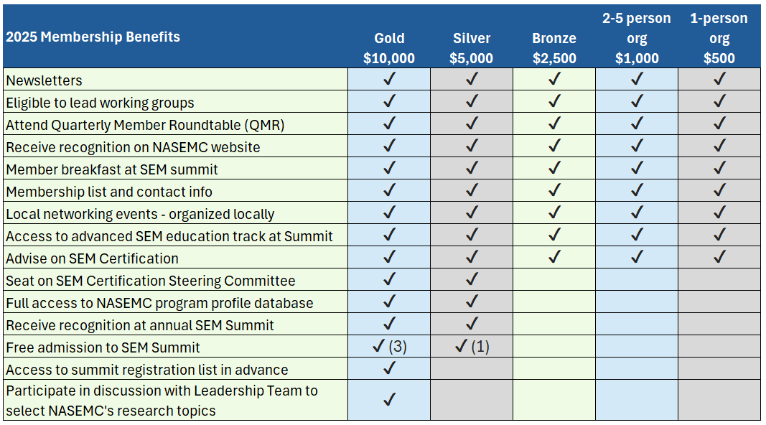

|  |  |  |  |
| --- | --- | --- | --- |
| FOR OFFICIAL USE ONLY | | | |
| Date received: | Date approved: | Membership #: | Name: |
| Once submitted, a member of the NASEMC leadership team will be in touch with you regarding your payment. | | | |